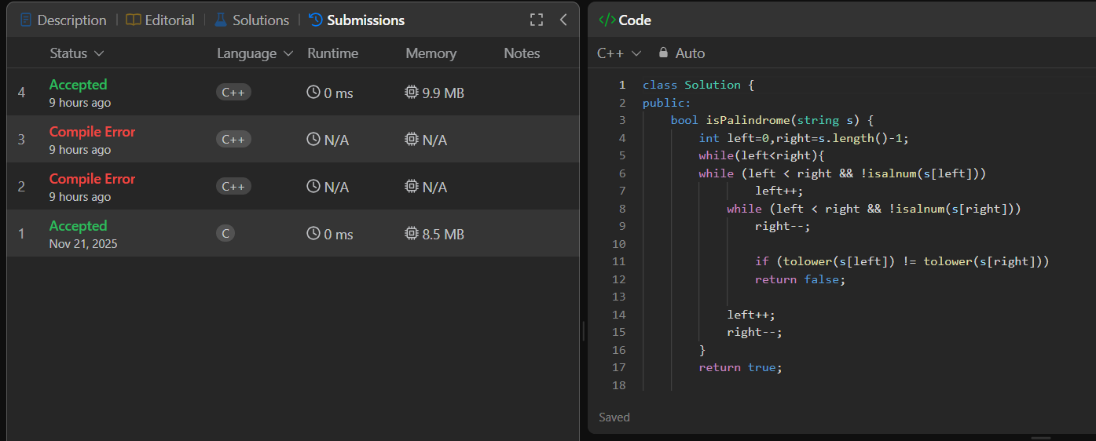
class Solution {
public:
bool isPalindrome(string s) {
int left=0,right=s.length()-1;
while(left<right){
while (left < right && !isalnum(s[left]))
left++;
while (left < right && !isalnum(s[right]))
right--;

if (tolower(s[left]) != tolower(s[right]))
return false;

left++;
right--;
}
return true;

}
};

